HINDALCO SUMMER TRAINING PROJECT REPORT
2026-27

HindConnect-Intelligent IT Helpdesk & Complaint Management Portal

Submitted By
Mr. Mukul Srivastav
Hindalco Industries Ltd.
(Aditya Birla Group)

Supervised By
Vishesh Kumar Singh
B.Tech – Computer Science and Engineering (Data Science)
Vellore Institute of Technology

CERTIFICATE

This is to certify that Mr. Vishesh Kumar Singh (Registration Number: 24BDS1058), student of B.Tech Computer Science and Engineering (Data Science), Vellore Institute of Technology, has successfully completed his summer internship at Hindalco Industries Ltd. (Aditya Birla Group) from 27 May 2025 to 25 June 2025.
During the internship period, he worked on the project titled “HindConnect — Intelligent IT Helpdesk & Complaint Management Portal.”
The project involved designing and developing a modern full-stack complaint management platform for IT issue reporting, tracking, and resolution. The system integrates intelligent features such as AI-powered ticket analysis, complaint categorization, real-time notifications, analytics dashboards, and chatbot assistance.
During the course of the internship, Vishesh demonstrated strong technical skills, dedication, problem-solving ability, and a professional attitude toward assigned responsibilities. His work was found to be satisfactory and appreciable.
We wish him success in all his future endeavors.

Industrial Mentor
Mr. Mukul Srivastav
Hindalco Industries Ltd.
(Aditya Birla Group)

ACKNOWLEDGEMENT
I would like to express my sincere gratitude to Hindalco Industries Ltd. (Aditya Birla Group) for providing me with the opportunity to undertake my summer internship in such a highly professional and technologically advanced environment.
This internship has been an invaluable learning experience, allowing me to gain practical exposure to enterprise-level problem solving, software development, and real-world IT workflows.
I am especially thankful to Mr. Mukul Srivastav, my industrial mentor, for his constant guidance, support, and encouragement throughout the internship. His valuable insights, technical knowledge, and mentorship helped me understand the practical challenges involved in building scalable enterprise solutions.
I would also like to thank the entire IT team at Hindalco for their cooperation and support during the development of this project. Their inputs regarding existing workflows and real-world problem scenarios played a crucial role in shaping the solution.
I would also like to express my gratitude to Vellore Institute of Technology, particularly the faculty members of the Computer Science and Engineering (Data Science) department, for providing the academic foundation and technical skills necessary to successfully complete this project.
Lastly, I would like to thank my family and friends for their constant encouragement and support throughout this journey.
This internship has greatly enhanced my technical skills, problem-solving ability, and understanding of enterprise software systems.

ABSTRACT
Hindalco Industries Ltd., one of India’s largest industrial enterprises and a flagship company of the Aditya Birla Group, operates across multiple business divisions including refineries, smelters, logistics hubs, finance departments, and corporate offices. Efficient operations across these units heavily depend on reliable IT infrastructure such as enterprise software systems, VPN connectivity, printers, hardware devices, SAP access, and internal communication tools.
In large-scale industrial organizations, IT-related disruptions can directly impact productivity and operational efficiency. Traditionally, IT complaint handling is often managed through informal channels such as phone calls, emails, or manual reporting. These methods create several challenges including delayed issue resolution, duplicate complaints, lack of visibility, poor accountability, and absence of centralized analytics.
To address these challenges, HindConnect was developed as an intelligent, centralized IT Helpdesk and Complaint Management Portal. The platform digitizes the entire complaint lifecycle, starting from ticket submission to issue resolution and performance analytics.
The system provides role-based access for three major stakeholders:
- Employees
- IT Staff
- Admins
Employees can raise structured IT complaints with supporting attachments. IT staff can receive, manage, prioritize, and resolve tickets through dedicated dashboards. Administrators can monitor operations, verify user registrations, track SLA compliance, and analyze complaint trends through visual dashboards.
A major highlight of HindConnect is its AI-powered capabilities. The platform integrates:
- Intelligent ticket categorization
- Complaint priority prediction
- Duplicate complaint detection
- AI chatbot assistance using Google Gemini
The AI chatbot provides instant IT support and can assist users in both English and Hindi/Hinglish, improving accessibility across different user groups.
The project is built using modern technologies including:
- React
- Node.js
- Express.js
- MongoDB
- Tailwind CSS
- Google Gemini AI
HindConnect successfully transforms traditional complaint management into a smart, scalable, and efficient digital ecosystem. The solution improves transparency, reduces resolution time, enhances productivity, and enables data-driven decision making for better IT service management.

INDEX

S.No | Topic | Page No
1 | Introduction | 6
2 | Objectives | 8
3 | Significance | 9
4 | Key Features | 10
5 | System Architecture | 15
6 | ER Diagram | 16
7 | Benefits | 17
8 | Implementation | 18
9 | Challenges Faced | 21
10 | Future Enhancements | 23
11 | Screenshots | 25
12 | Conclusion | 26

INTRODUCTION
Hindalco Industries Ltd. is one of India’s largest producers of aluminum and copper and operates across multiple industrial facilities, refineries, smelters, logistics centers, and corporate offices. As a large-scale enterprise, Hindalco relies heavily on robust IT infrastructure to ensure seamless business operations across departments.
Every department depends on IT services for critical day-to-day operations such as:
- Network connectivity
- ERP systems like SAP
- VPN access
- Printer services
- Hardware availability
- Email and communication systems
Any disruption in these services can significantly affect productivity and operational continuity.
Traditionally, complaint handling in many large organizations is managed through emails, phone calls, or manual communication with IT teams. Although widely used, these methods suffer from several limitations.
Problems with Traditional Complaint Management
1. No Centralized Reporting System
Employees use multiple channels to report issues, leading to scattered complaint records.
2. Poor Complaint Visibility
Once an issue is reported, employees often have no way to track progress or status.
3. Delayed Resolution
Lack of structured workflows results in slower complaint handling.
4. No Priority Management
Critical and non-critical issues may receive equal attention despite different business impacts.
5. Lack of Accountability
No proper audit trail exists to determine who handled which complaint and when.
6. Limited Communication
There is often no structured communication channel between employees and IT teams.
7. No Analytics
Management lacks insights into recurring problems, resolution times, and IT performance.
These limitations create inefficiencies and increase downtime across business operations.
To solve these challenges, HindConnect was developed as a centralized digital complaint management platform specifically designed for enterprise IT issue handling.
The platform enables:
- Centralized complaint submission
- Structured ticket lifecycle management
- Role-based dashboards
- SLA monitoring
- AI-powered complaint analysis
- Real-time notifications
- Analytics dashboards
- AI chatbot support
HindConnect modernizes traditional IT complaint management by combining modern web technologies with artificial intelligence.

OBJECTIVES
The primary objective of HindConnect is to build an intelligent, centralized, and efficient complaint management platform for handling IT-related issues within Hindalco Industries Ltd.
The key objectives are:
- To provide a centralized platform for complaint reporting
- To digitize the complaint lifecycle
- To implement role-based dashboards
- To improve complaint tracking
- To reduce issue resolution time
- To integrate AI-powered ticket analysis
- To provide chatbot-based instant support
- To improve communication between users and IT teams
- To provide analytics dashboards for management
- To enforce SLA compliance

SIGNIFICANCE
HindConnect plays a crucial role in improving IT support operations within Hindalco Industries Ltd.
Operational Efficiency
The platform centralizes complaint management and eliminates delays caused by manual reporting.
Transparency and Accountability
Employees can track every complaint from submission to closure.
Reduced Resolution Time
AI-assisted prioritization and SLA tracking improve response speed.

Better Communication
Structured communication reduces confusion between employees and IT teams.
Data-Driven Decision Making
Management gains valuable insights into system performance and issue trends.

KEY FEATURES
1. Landing Page
Professional corporate landing page aligned with Hindalco branding.
2. User Registration
Detailed registration form for employee onboarding.
3. Admin Verification
Admin approval workflow for secure access.
4. Role-Based Login
Separate dashboards for Employee, IT Staff, and Admin.
5. Employee Digital Dossier
Digital employee profile with personal and emergency details.
6. Complaint Submission
Employees can submit complaints with title, description, priority, category, and attachments.
7. AI Ticket Analyzer
Provides:
- Predicted category
- Priority
- Duplicate detection
- Troubleshooting steps
8. Employee Dashboard
Displays complaint history and live status.
9. IT Staff Dashboard
Dedicated workspace for ticket resolution.
10. Admin Dashboard
Analytics, ticket management, and user management.
11. Notifications
Real-time system notifications.
12. Knowledge Base
Self-service IT solution repository.
13. AI Chatbot
Gemini-powered chatbot with Hindi/Hinglish support.
14. Responsive Design
Accessible across desktop, tablet, and mobile.

SYSTEM ARCHITECTURE
HindConnect follows a full-stack architecture.
Frontend Layer
- React 19
- Tailwind CSS
- Vite
- Recharts
- Framer Motion
Responsibilities:
- UI rendering
- State management
- API communication

Backend Layer
- Node.js
- Express.js
Responsibilities:
- Authentication
- Ticket handling
- Notifications
- Analytics
- AI integration

Database Layer
- MongoDB Atlas
- JSON fallback database

AI Layer
Ticket Analyzer
Rule-based NLP engine for:
- Classification
- Priority prediction
- Duplicate detection
AI Chatbot
Google Gemini-powered assistant.

ER DIAGRAM
Major entities:
- Users
- Tickets
- Comments
- Notifications
- Knowledge Base
- Activity Logs

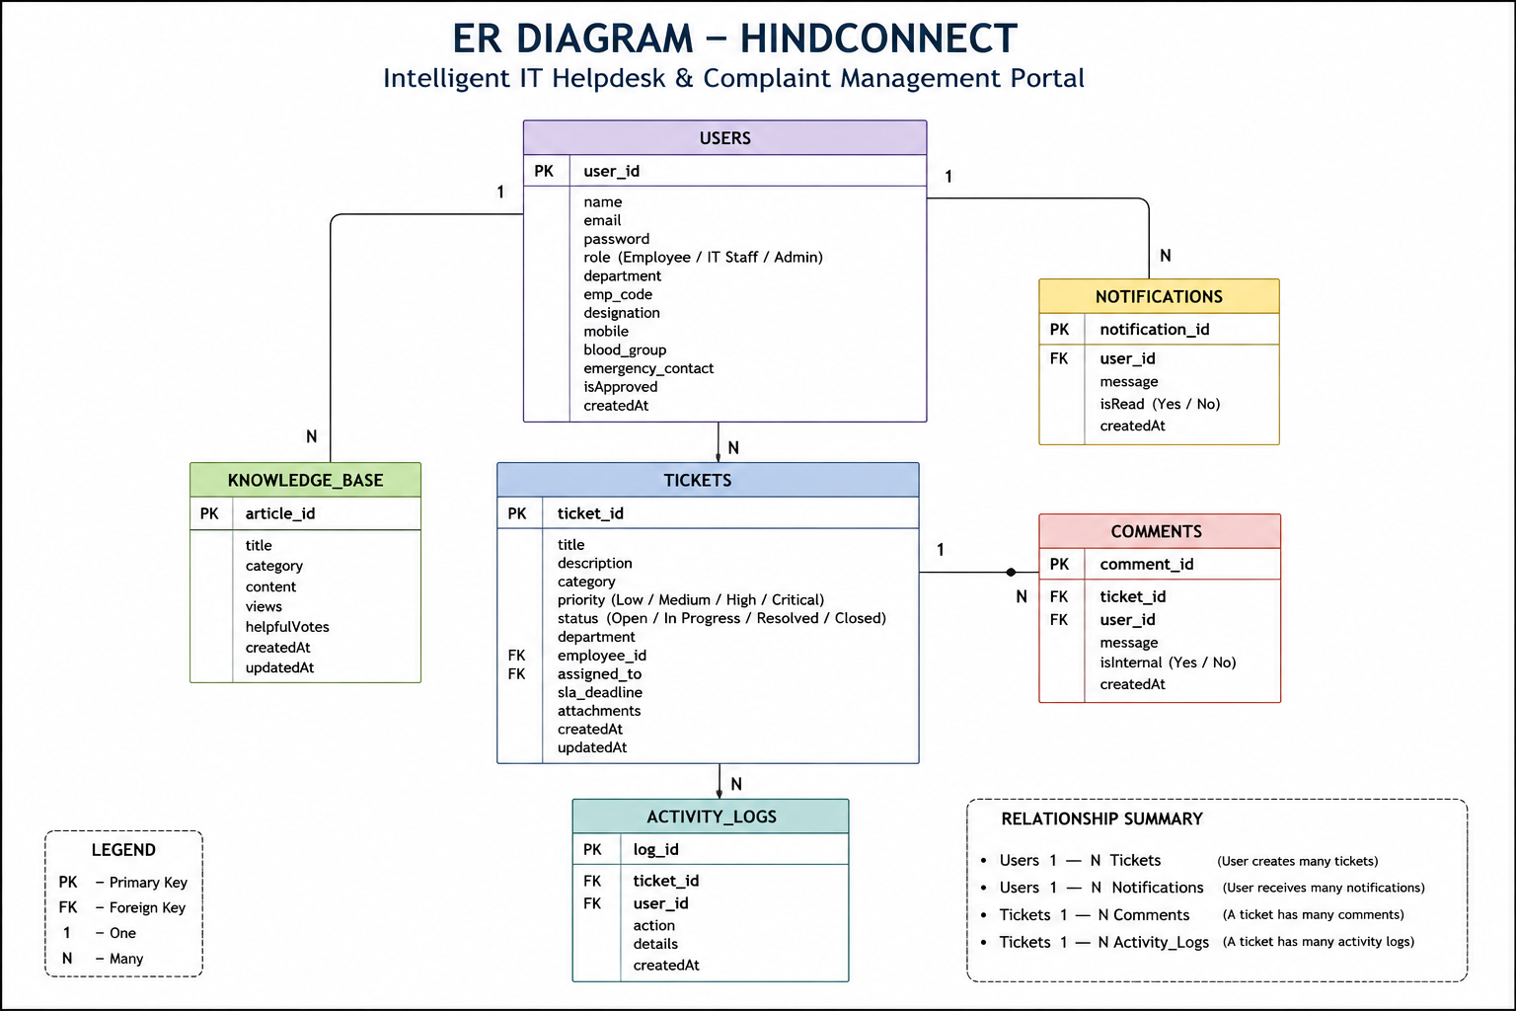

BENEFITS
For Employees
- Easy complaint submission
- Real-time tracking
- Faster support
For IT Staff
- Organized ticket queue
- Better workload management
For Admins
- Full operational visibility
- Analytics dashboards
For Hindalco
- Reduced downtime
- Better productivity

IMPLEMENTATION
Frontend Implementation
Built using React 19 with Tailwind CSS.
Backend Implementation
Developed using Node.js and Express.js.
Database Implementation
MongoDB Atlas with JSON fallback.
AI Implementation
Ticket Analyzer
Rule-based NLP engine.
AI Chatbot
Google Gemini AI.

TECHNOLOGY STACK
Category | Technology
Frontend | React, Tailwind
Backend | Node.js, Express
Database | MongoDB
Authentication | JWT
AI | Google Gemini

CHALLENGES FACED
During development, several technical challenges were encountered.
1. Database Connectivity Issues
MongoDB authentication and connection failures caused instability.
Solution
Implemented dual-database architecture.

2. Role-Based Dashboard Complexity
Managing multiple dashboards and permissions was complex.
Solution
Implemented role-based routing.

3. Authentication Challenges
Secure access control was essential.
Solution
Implemented JWT authentication.

4. File Attachment Handling
Managing uploads and storage was challenging.
Solution
Implemented Base64-based storage.

5. AI Integration
Balancing AI speed and accuracy was difficult.
Solution
Used hybrid AI architecture.

6. SLA Tracking
Tracking deadlines dynamically was complex.
Solution
Implemented custom SLA logic.

FUTURE ENHANCEMENTS
Potential future upgrades include:
- Mobile application
- Email notifications
- Advanced AI ticket classification
- Predictive issue detection
- Smart recommendation engine
- SAP integration
- Single Sign-On (SSO)
- Advanced analytics

SCREENSHOTS
Landing Page
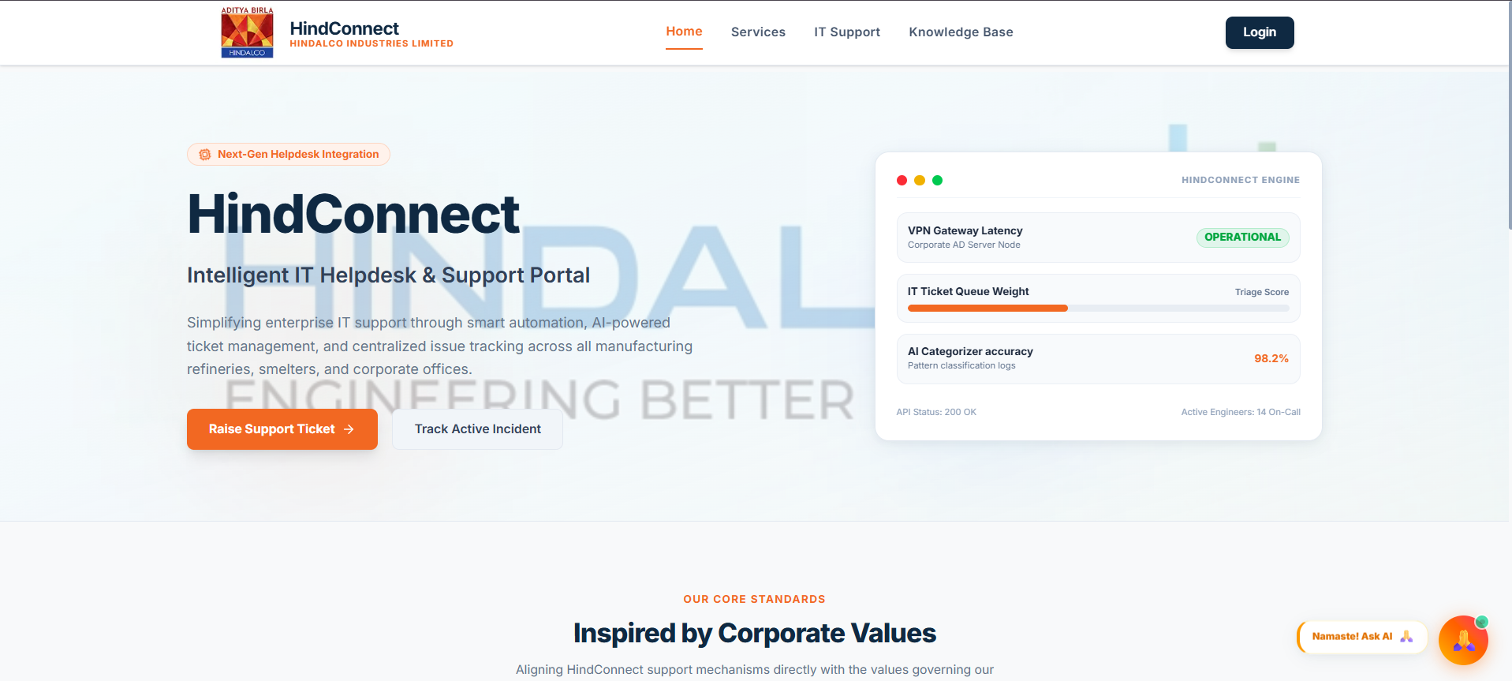
Login Page
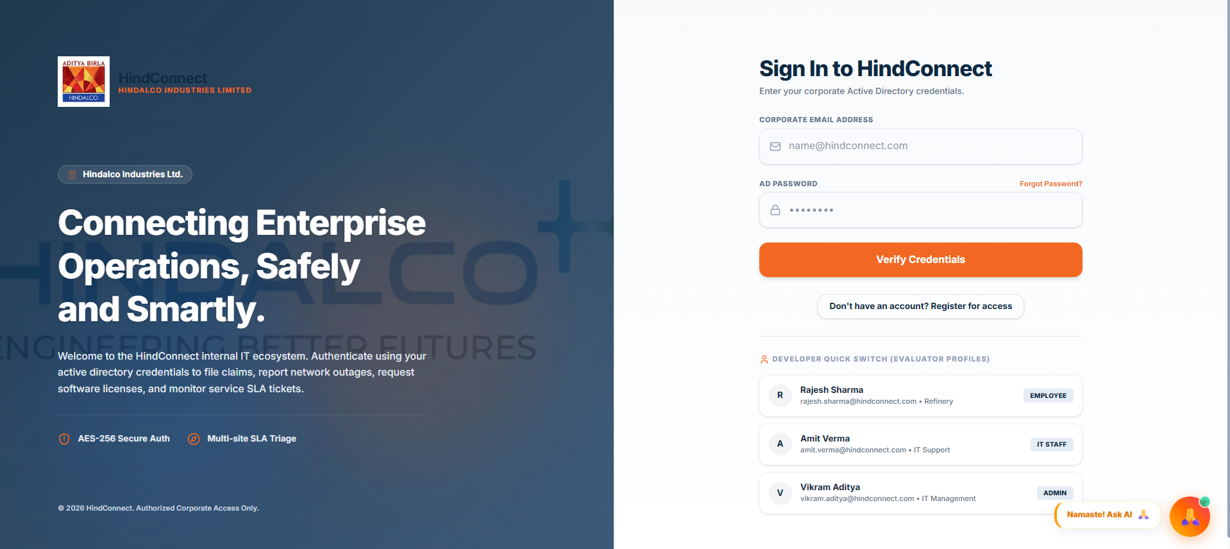Registration Page
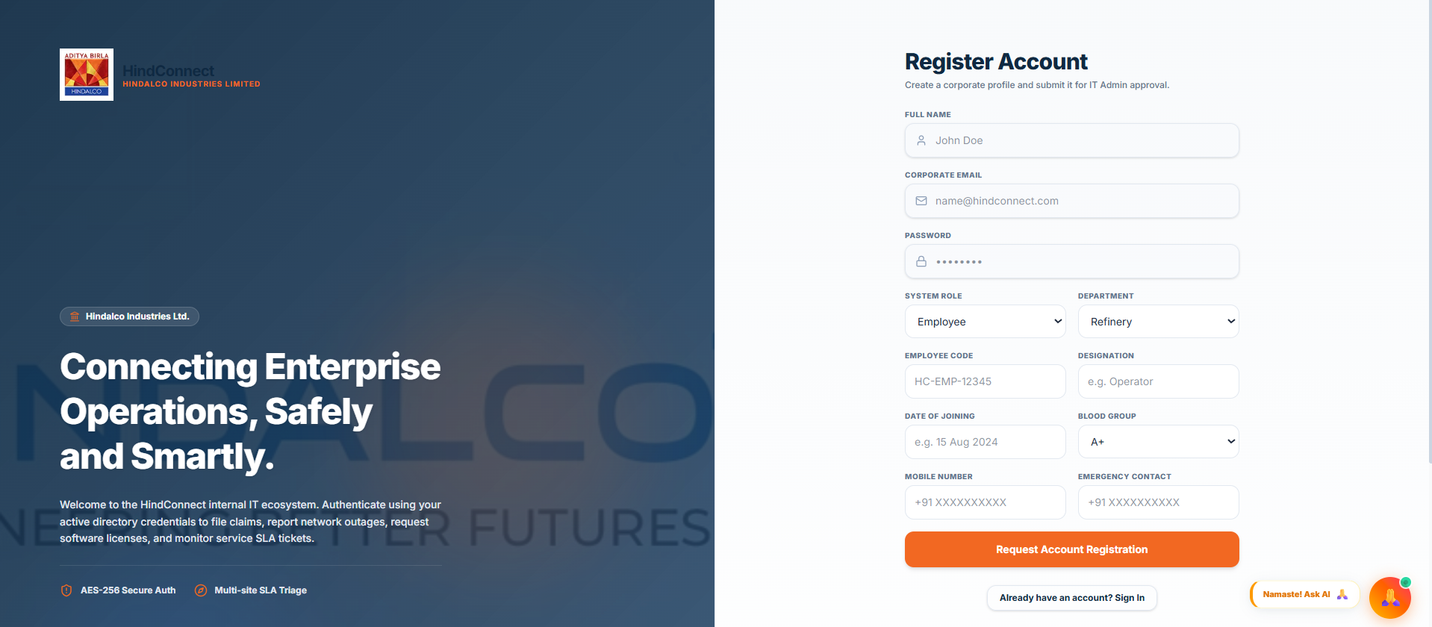
Employee Dashboard
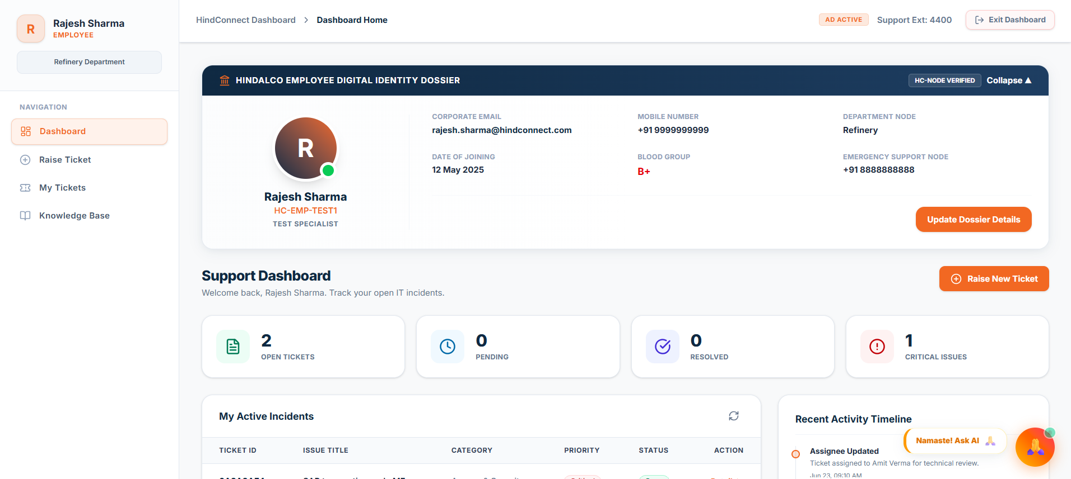Ticket Submission
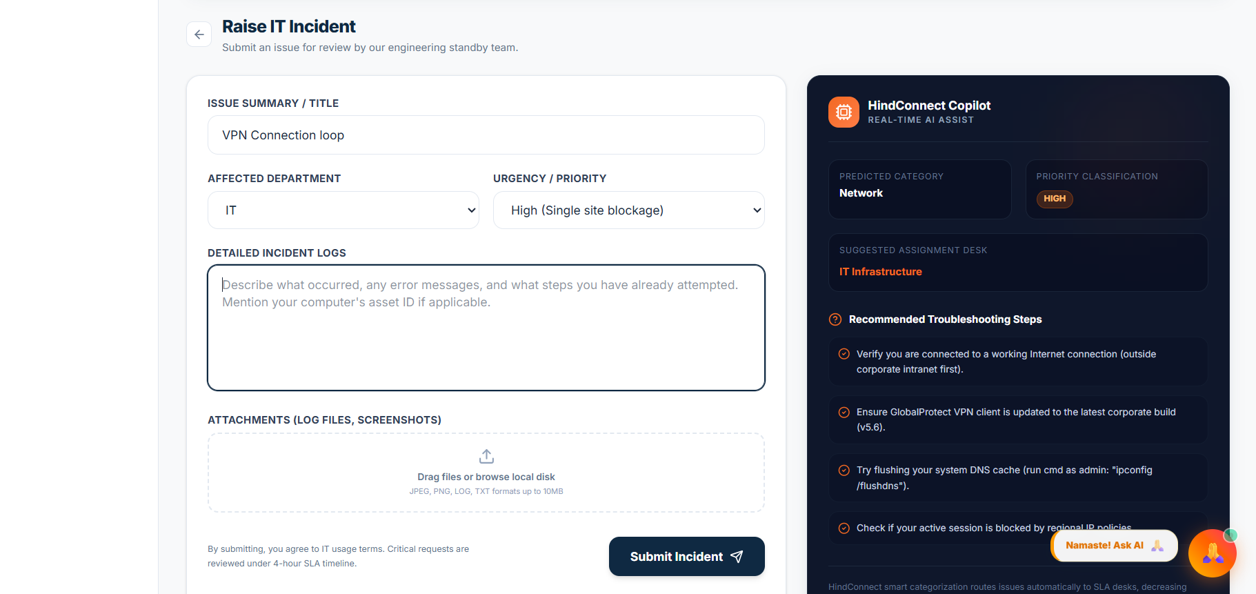
Admin Dashboard
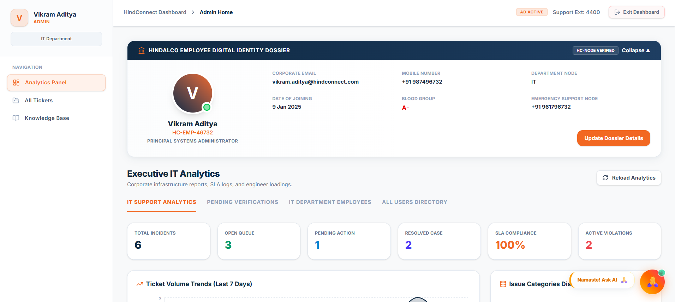
Analytics Dashboard
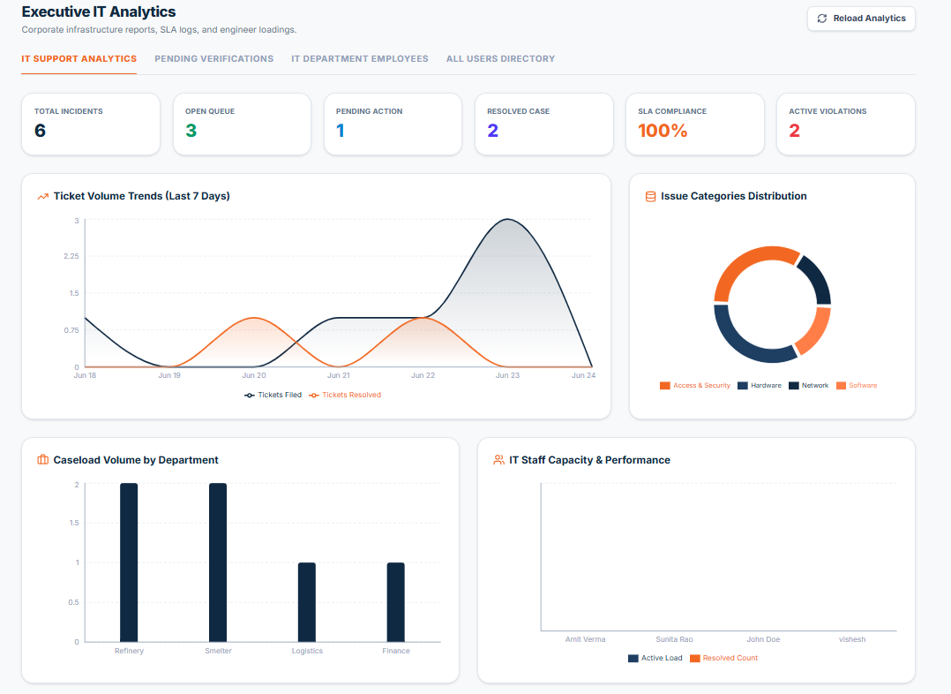AI Chatbot
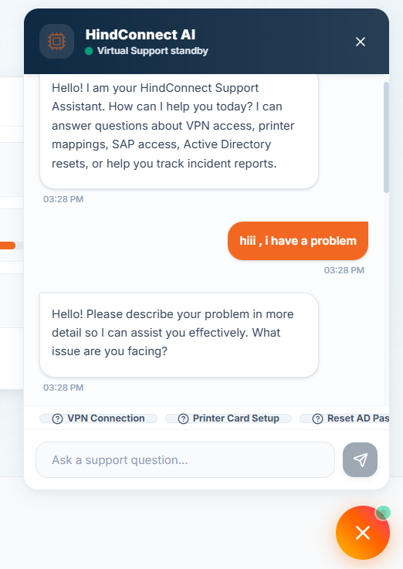
CONCLUSION
HindConnect successfully addresses the limitations of traditional IT complaint management systems by introducing a centralized, intelligent, and scalable solution for complaint handling at Hindalco Industries Ltd.
The platform improves operational efficiency, enhances transparency, reduces resolution time, and strengthens communication between employees and IT teams.
The integration of AI-powered ticket analysis and chatbot support significantly improves user experience and reduces manual workload.
This project demonstrates the practical application of:
- Full-stack development
- Database management
- Authentication systems
- AI integration
- Enterprise workflow automation
HindConnect has strong future potential and can evolve into a complete enterprise IT service management platform with advanced automation and analytics.

